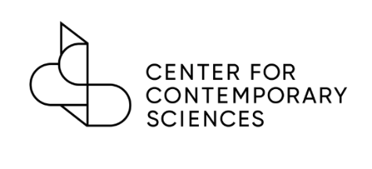

Students for Contemporary Sciences Chapter Requirements

To be affiliated with the Center for Contemporary Sciences, a student organization must:

- Be a recognized, or in the process of becoming a recognized, student organization with their school.

- Agree to and sign the Students for Contemporary Sciences Agreement.

- Include the Center for Contemporary Sciences Program Manager, Mikalah Singer, in your chapter’s public email list.

- Have at least two active members.

- Provide a list of officers and their email addresses for the current academic year using the online form no later than October 1 every year. New chapters may form at any time.

Association with the Center for Contemporary Sciences:

- Students for Contemporary Sciences Chapters may advertise that they are affiliated with the Center for Contemporary Sciences and will be recognized on the CCS website.

- Student chapters have the option, and are encouraged, to use the Students for Contemporary Sciences logo on social media pages including but not limited to, Facebook pages, Twitter accounts, and Instagram accounts.

- The Center for Contemporary Sciences can provide free tabling materials including brochures, stickers, and signs to use at events.

- Student Chapters members can benefit from networking and teaching opportunities, internships with professionals in the field including with CCS team and Advisory Council members, experience developing and working on campaigns with the Center for Contemporary Sciences and their partner organizations, experience developing and working on campaigns with the Center for Contemporary Sciences and their partner organizations.

Benefits:

While in school, students are presented with countless opportunities to not only learn about their own interests, but to start making connections that can help those interests become a viable career choice. CCS wants to provide a space for students to explore the interconnection between the fields of public health, the environment, and animal protection while also supporting student efforts to make tangible change for our future. Students have experienced effects of human mistreatment of the environment and animals personally with COVID-19 and other zoonotic diseases resulting from wildlife trade and animal agriculture, slowed drug development because of ineffective animal testing, and an increase in extreme weather events from climate change. They are ready to see change and have the power to bring it about. We want to support and work with them to unlock the power of science to find solutions that improve the health and wellbeing of humans, animals, and the planet.

The Student Chapters of CCS provide a forum for students interested in public health and the intersection of how we treat animals and the environment. Students will be able to discuss freely the issues around legislative proposals related to animal agriculture and replacing animal testing with biomedical research methods based on human-biology such as the FDA Modernization Act, Preventing Future Pandemics Act, and Farm System Reform Act. Additional focus can be on the technological advancements such as lab-grown organs, in silico computer modeling, and organ-on-a-chip technology.

Please contact the Center for Contemporary Sciences Program Manager, Mikalah Singer, with any questions.

